**Let’s understand how docker works**

* Container can be defined as isolation with some resource limits 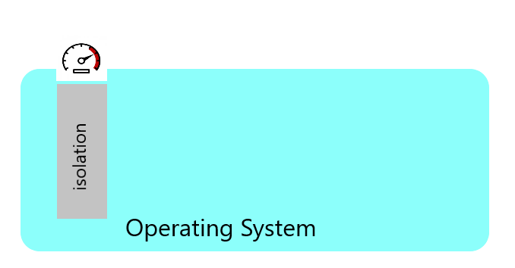
* So, host system can create multiple different containers 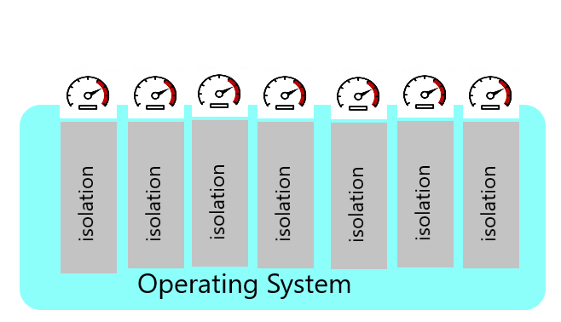

**How are Isolations Created & Resource Limits Applied ?**

* Isolations on the linux machines are created using a linux kernel feature called Namespaces.
* Resource Limits are applied using kernel feature called as cgroups (Control groups).

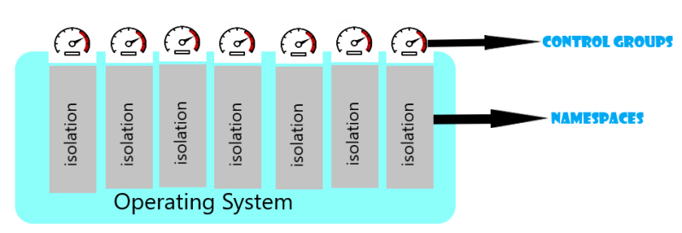

* Working on namespaces & cgroups are difficult, but here comes the docker to the rescue.
* Docker Engine makes it easy to create isolated areas & resource limits

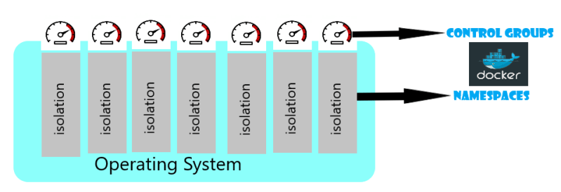

**Namespaces**

* Namespaces is a linux feature.
* There is an interesting article on namespaces over. (Link: https://www.toptal.com/linux/separation-anxiety-isolating-your-system-with-linux-namespaces)

**pID** namespace (Process Namespace) creates the isolated process tree inside container 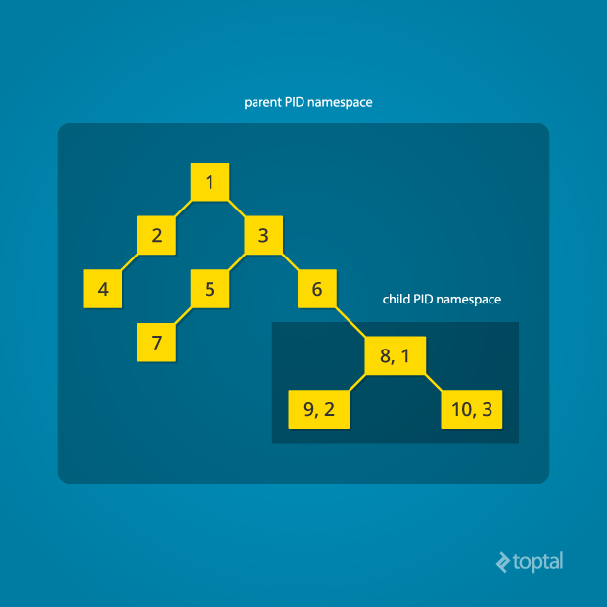

**net** namespace (Network Namespace) creates the isolated networking for each container with its own network interface.

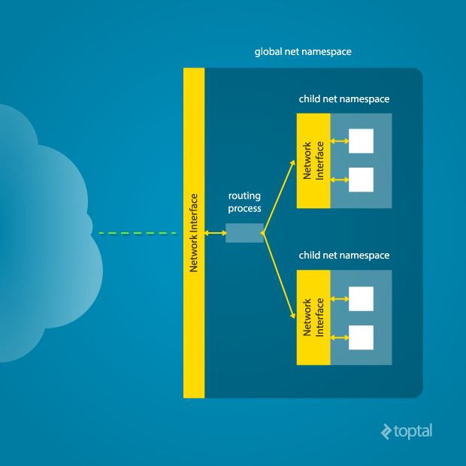

**mount** namespace creation allows each container to have a different view of entire systems mount point, this allows containers to have their own file system view which starts from root

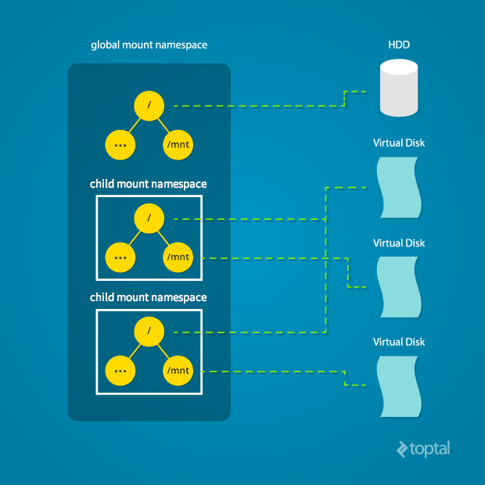

**user** namespace allows to create whole new set of user & groups for the containers

**cgroups (control groups)**

* cgroups is a linux kernel feature
* Control groups is used to impose limits. We can impose limits of disk io, RAM & cpu’s using ControlGroups
* Fortunately even in windows world we have control groups now. The purpose of the namespace is same but underlying implementation differs.

**Containers also have Layers for Filesystems**

**Docker Underlying Components**

The underlying components of docker as per the latest implementation is looking as shown 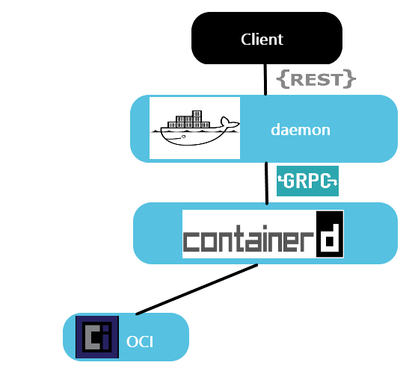

The Specific Linux Implementation will be shown below 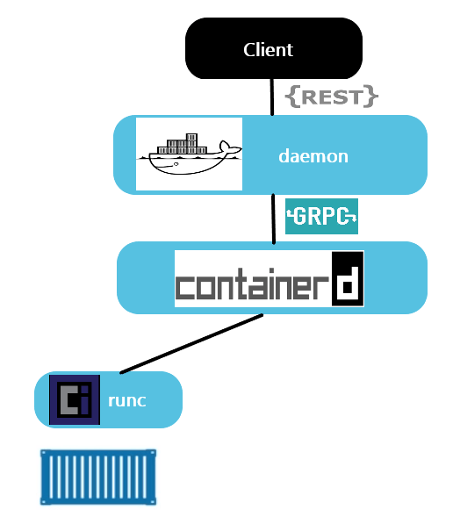

The Specific Windows Implementation will be as shown below 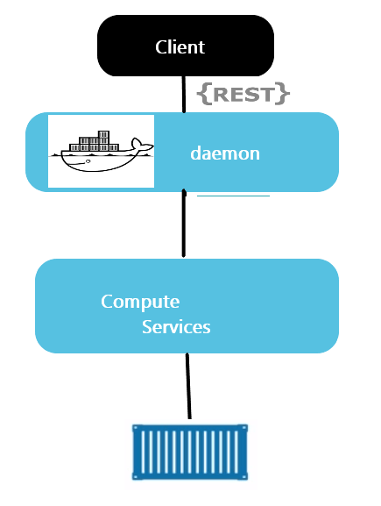

In the below example i have create one container and this container is running 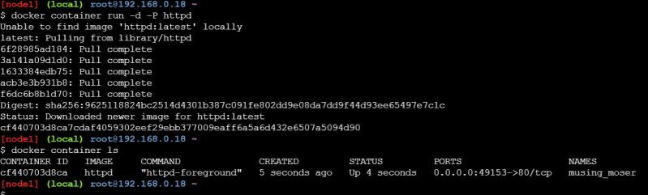

* What exactly is happening under the hood
* Before we understand what is happening lets do some experiments

Lets execute top on the vm where docker is installed 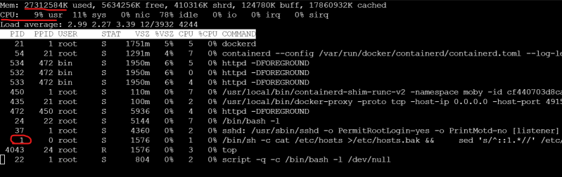

Now lets examine the storage in the vm where docker is installed (host) 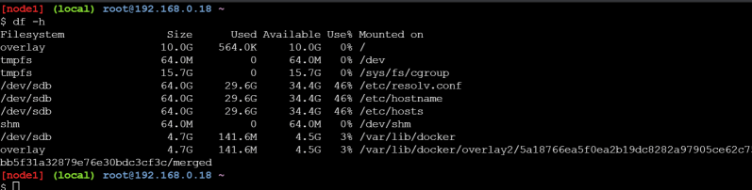

On the machine we have cpu, ram and storage and the operating system is creating processes to run applications

Let me create a alpine container and log in to the container 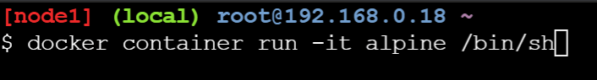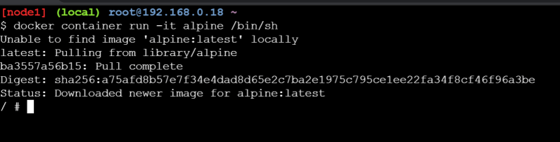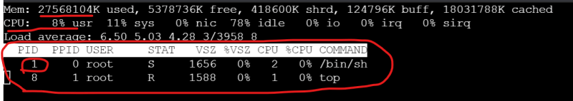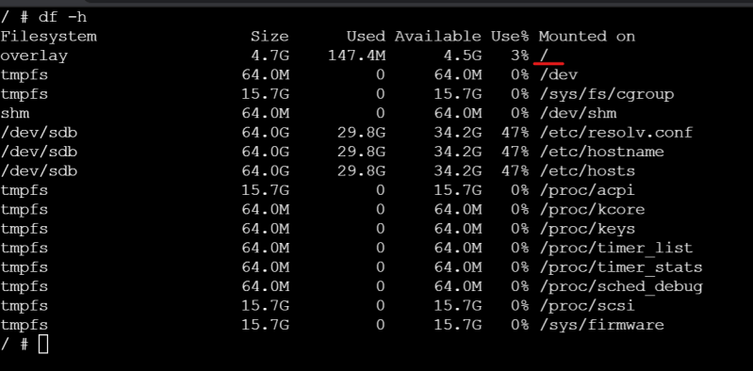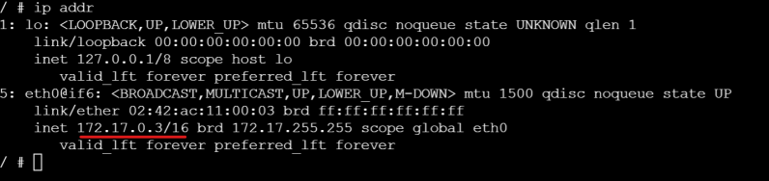

* + Inside the container we have cpu, ram, process tree, disks and we have network
* We are referring to the containers as isolations. These isolations recieve
  + an disk storage with os
  + network interface to connect to network
  + cpu
  + ram
* In linux these isolations are created by a feature of linux kernel which is called as *Namespaces* & the Resource Limits is applied to isolation using a feature called as *control groups*
* Docker has made it simple to create isolations and applying resource limits
* In linux we have different namespaces
  + pID namespace (process namespace)
  + net namespace
  + mount namespace

The resources are applied to your system using control groups 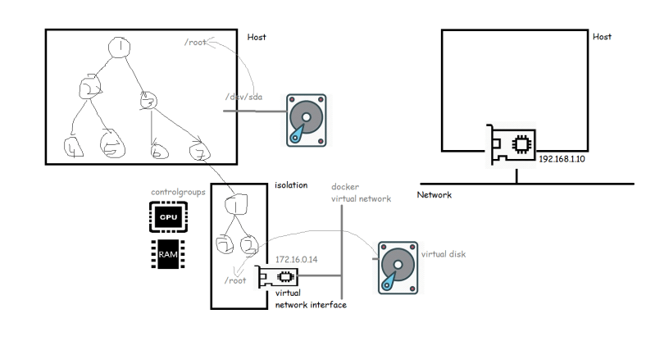

**Lets try to understand docker architecture and how the container is created in docker.**

* Docker Engine is the core software that runs and manages containers
* When docker was first released docker engine had two major components
  + Docker daemon:
    - It had all the code for the docker client, docker api and runtime, image builds etc.
  + LXC: provided the docker daemon with access to fundamental building blocks of container like namespaces and control groups 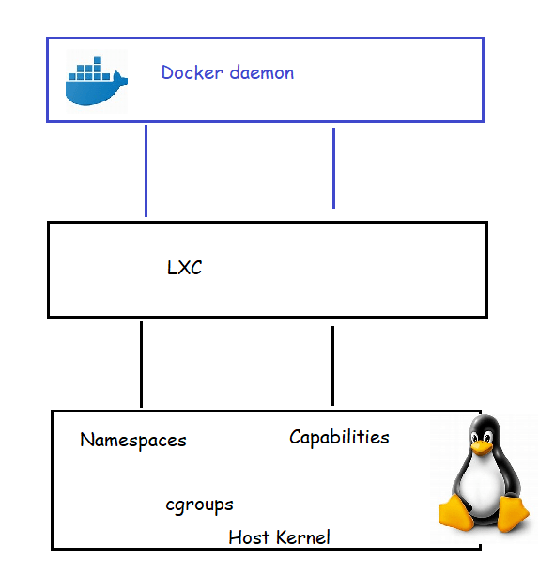
* LXC is linux-specific, which was from linux opensource project. Whenever there was a new release of linux kernel and changes in the lxc would impact docker containers
* Docker Inc. developed their own tool called as libcontainer as a replacement for LXC.
* Docker has become huge success and docker had started adding lot of features, These features made docker fat
* During this time frame a company called as CoreOS (acquired by RedHat acquired by IBM) didn’t like the way docker did certain things, so they created a open standard called as appc. The implentation of this spec called as rkt (rocket)
* Docker has started working with many organizations to build OCI (open container initiative)
* OCI published two specifications (standards)
  + the image-spec
  + the runtime-spec

**Docker architecture:**

* docker as a technology relies on three things
  + The runtime:
    - This works at lowest level and is responsible for starting,stopping, creating containers which means this speaks with os constructs such as namespaces and cgroups
    - The low level runtime is called as *runc* (This is reference implementation of OCI runtime-spec). Job of runc is to interface with underlying OS and to start and stop containers. Every running container on a docker has a runc instance managing it
    - The higher-level runtime is called as *containerd* and this manages the lifecycle of container including pulling images, creating network interfaces and managing run-c
    - In Typical docker installation has a single containerd process and runc instances are associated with each container.
  + The daemon (engine)
    - The docker daemon (dockerd) sits above containerd and performs higer level tasks such as exposing Docker remote API, managing images, managing volumes, managing networks etc
    - When we want to create a cluster of nodes running Docker, then this Orchestrator comes into play